**Mohammed Mahin Ibnay Mamun (346584)**

**Task 1 - Principles of Digital Imagery (P1, P2, M1, D1)**

**1a. Explain how digital data can be used to represent images.**

**Raster**

Raster graphics can also be referred to as a bitmap. They are made up of small dots on a grid which build pixels. These graphics are modified in paint software. These graphics also have a fixed resolution and cannot be resized without altering the quality of the image.

A raster file is built up with pixels. A pixel is an image or graphic that can be represented on digital displays with pixels, the smallest units of this image or graphics. Each pixel can be used to represent a specific color assigned to it through its color value. The image below shows an example of this. The quality of the image is better if the number of pixels is higher.

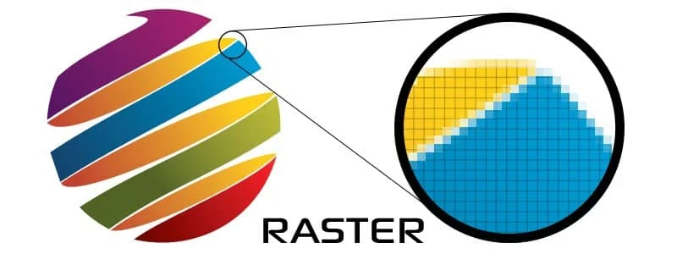Raster files are well known for art made digitally such as drawing, photos, and complex graphics such as digital drawing or painting. They can also be used for simple graphics and logo designs based on the type.

Advantages of Raster images:

* Each individual pixel can be edited.
* High range of colors to choose from and details to add.
* Quality is high depending on the resolution.
* Can be saved in several formats.

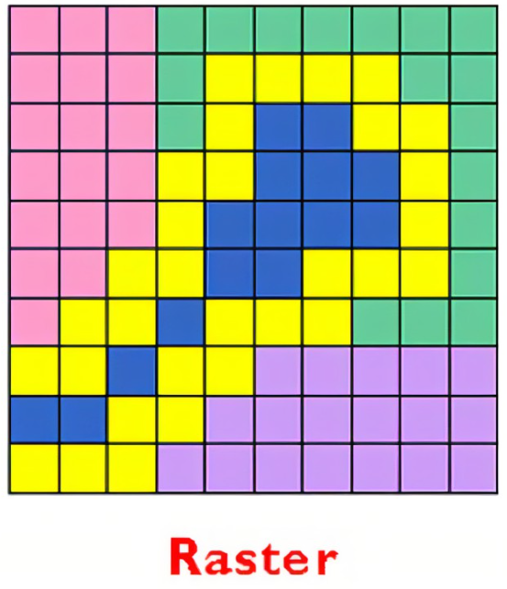

**Resolution**

A measure of resolution is used to characterize the clarity and sharpness of an image or picture. This can be printed on a monitor, phones, tablets, tv and computers.

When resolution increases, images become clearer due to a higher pixel density. By adding more pixels, we can increase the resolution and quality.

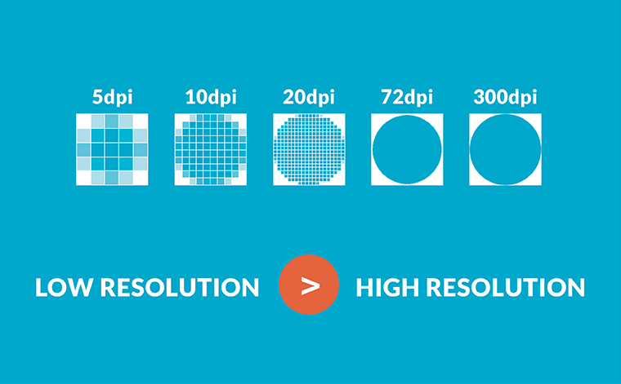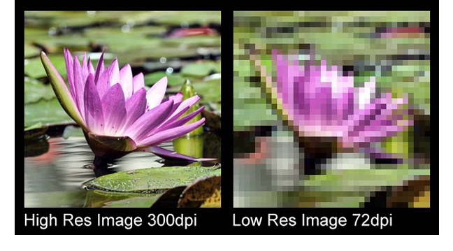

Below is a table with some common resolutions based on monitor size.

|  |  |
| --- | --- |
| Monitor size | resolution |
| 19 inches | 1680 x 1050 |
| 21 inches | 1920 x 1080 |
| 23 inches | 1920 x 1080 – 2560 x 1440 |
| 27 inches | 2560 x 1440 – 3840 x 2160 |

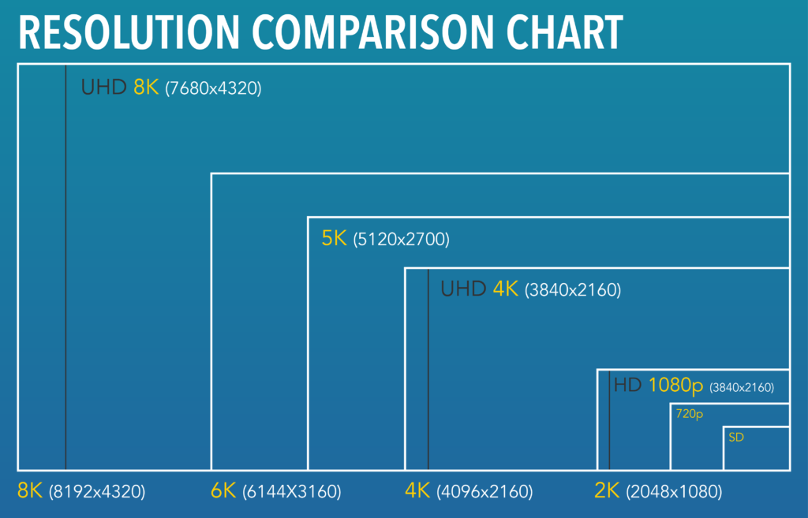

**Sampling**

A technique for turning an analogue audio signal into a digital signal is sampling. When a sound wave is being sampled, the computer measures it at regular intervals known as sampling intervals. The result of each measurement is then recorded as a binary number.

The number of samples, or measurements, of the sound that are taken per second is known as the sampling rate. The audio quality improves and more information about the locations of the waves rise, and fall is captured as more samples are collected. Additionally, the sound wave's shape is more precisely captured.

Each sample reflects the digital signal's amplitude at a particular instant in time. The amplitude is encoded as a binary number and saved as either an integer or a floating-point number.

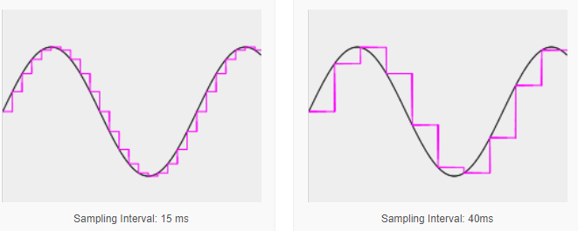

**Colour modes / bit depth**

To select a certain shade of a color, you can use the hex color picker. By using this tool, you get a 6-digit hexadecimal value. The number is followed by a # and then the first 2 digits of the value represent the red. Middle two digits represent the green and last 2 represents the blue.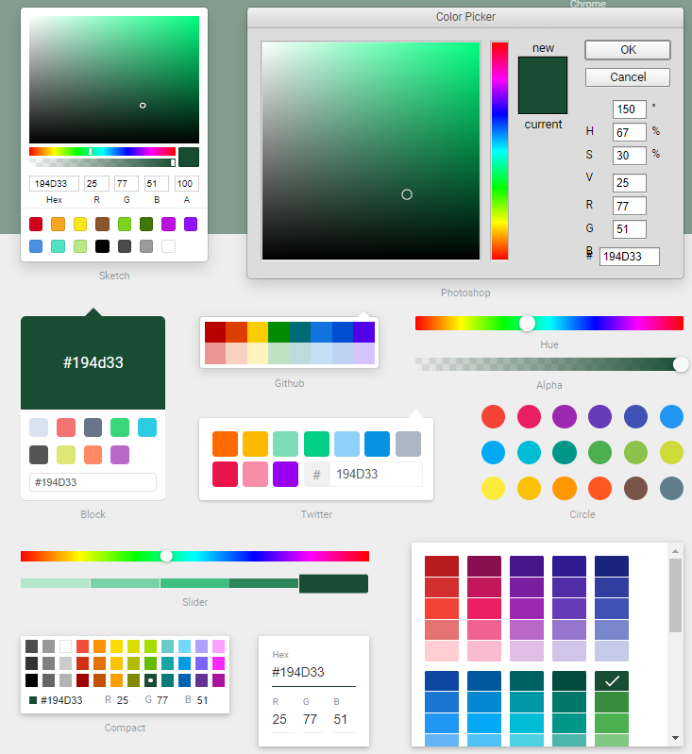

The table below shows how color is made in an image. Having a higher color bit depth allows you to have access to more colors and shades for your image. On the downside, having a higher color bit depth result in a higher file size. However, 8 bit is the most used.

|  |  |
| --- | --- |
| **Common bit depth** | **Number of colours** |
| **1 bit** | **2** |
| **2 bit** | **4** |
| **3 bit** | **8** |
| **4 bit** | **16** |
| **5** **bit** | **32** |
| **6** **bit** | **64** |
| **7** **bit** | **128** |
| **8** **bit** | **256** |

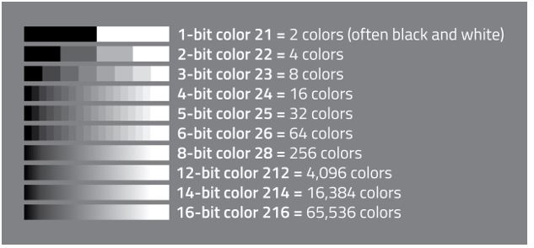

**Compression methods**

Files with exceptionally big sizes are frequently produced by modern computers. For instance, high quality video files can be stored in Gb while audio files frequently reach the Mb scale. Many files and images are large and take up drastic amounts of space.

**Lossy**

When using lossy compression, some material is eliminated and deleted, which lowers the overall volume of data and the file's size.4

For example, lowering the colour depth of an image, compression can be achieved. As a result, the image's colour spectrum is constrained. Another example is, Comparable to text files, audio files can be compressed by lowering the samples' bit depth.

For audio, including music, MP3 uses a lossy format.

Due to audio and video compression, the MPEG file format is better suited for streaming media.

This idea underlies the JPEG file format, which is why JPEG files typically have a lesser size.

**Lossless**

Using lossless compression, no data is lost when the file size is decreased. Lossless compression, meanwhile, rarely reduces file sizes as much as lossy compression.

Text documents can be compressed without loss using PDF.

The lossless picture file format is GIF.

A notable example of lossless is run length encoding.

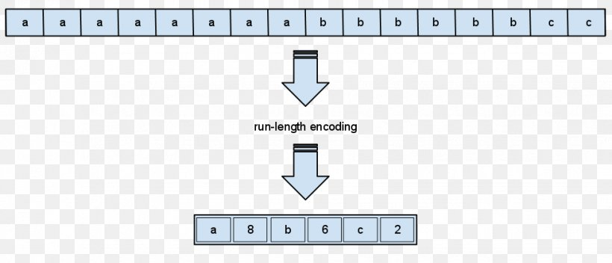

**Vector images**

The mathematical correlations between the control points that make up an image are the foundation of vector images. Each pixel is not individually recorded. The paths and curves between these points are referred to as vectors. 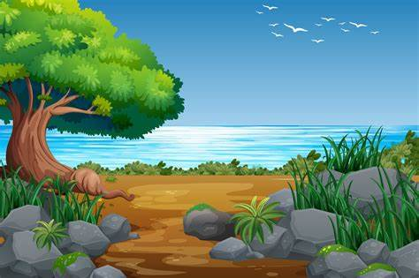

In contrast to bitmap images, vector images do not contain data about each individual pixel. A vector graphic would have a less file size than a bitmap image for a huge design, like a banner.

A vector image does not degrade quality when it is resized due to mathematical relationships. A postcard vector design could be rescaled and utilized as a banner while maintaining the clarity of the picture.

**Primitives**

A primitive in computer graphics is a basic building block whereby more complex visuals can be created, for instance an arc, a square, or a cone. Primitives are simple, non-interactive components that are presented on a computer. A complicated image can often be made by combining several simple pieces.

Primitives are made up of boxes, cones, spheres, geospheres, cylinders, tubes, and pyramids.

**Paths**

An arrangement of connected lines, slopes, and many other basic graphic elements, such as squares, ellipses, and typography, is known as a graphical path. Because a path functions as a single graphics object, any impact given to the graphics path will also be added to all the path's individual parts.

**Nodes**

A node in graph theory is a piece of data related to other nodes by edges on a structure. In graphical design, a node is simply a corner piece.

**Voxels**   
Voxels are proficiently 3D pixels, although they are perfect cubes rather than squares. Voxels are the ideal modelling tool for accurately recreating reality, in principle.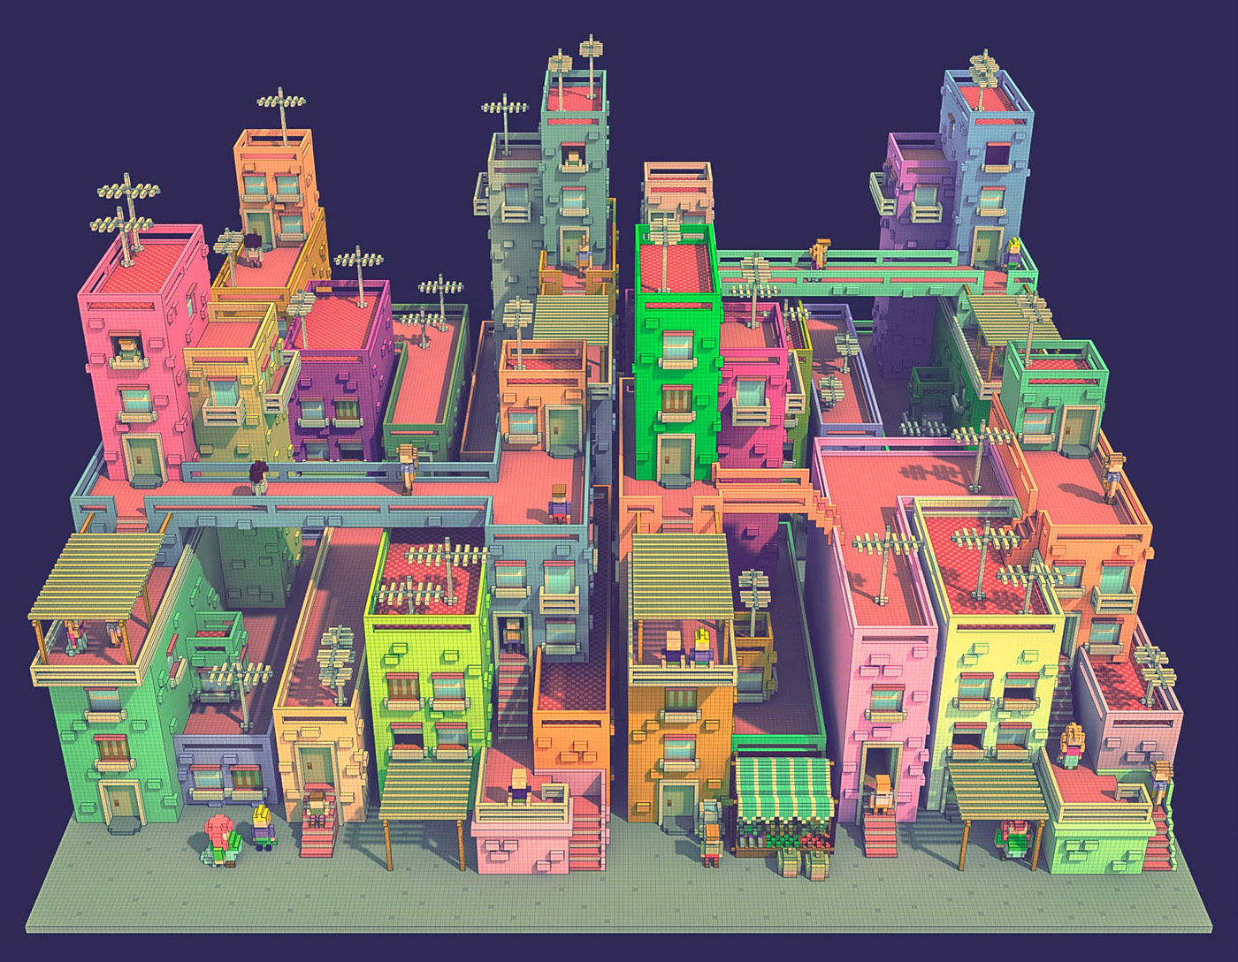  
  
  
**1b. Explain in some detail how 3D images are stored digitally. You should discuss the following:**

**Coordinate Systems**

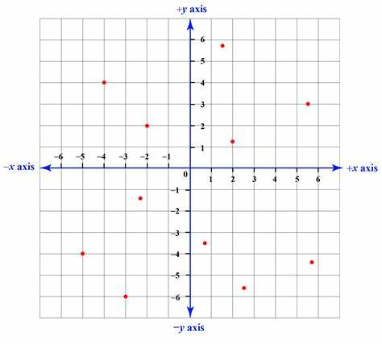A coordinate system is a method for figuring out where a point or other three - dimensional object is located within a greater area structure. Users can use the graph to locate their image on a bigger framework or even a specific part. To do this, we use the XY graph.

**Left/right hand**

The way this is done is by forming a shape with your hand to see the positive values of the axis. Users will observe that between left-handed and right-handed systems, positive Y and positive X correspond orientation, although positive

To try this, you need to put your left hand out with the fingers pointing up and your thumb needs to be pointing to the right. By doing this you can see that because your thumb is pointing right, it is showing positive and the fingers pointing up are also positive.

**Local**

Three reference locations or model nodes are required to establish a local coordinate system. The following definitions apply to the x, y, and z axes given three different points:

* The origin is defined by Coordinate 1.
* The local x direction is specified by coordinate 2.
* The XY plane is defined by coordinate 3, with the local Y axis passing through coordinate 3 nearest.

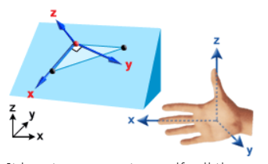

**3D world**

3d world is a workspace which allows you to model and design your own 3d project. The software has many features which allow you to create a very efficient 3D model.

**3D Viewport**

A viewport is a workplace pane. You may modify your viewports in several software applications to maximize the efficiency for someone productivity. It allows you to view your 3d model from the following angles: top, sides and bottom.

**Cameras**

We can install 3D devices that function like film cameras, called cameras. They can be used to capture animations, still photos, and more.

Cameras show a scene from a specific viewpoint. Camera objects mimic real-world still-image, moving-image, or video cameras.

Viewports can be configured to show the camera's point of view when a camera has been built. You can manipulate the camera as if you were looking through its lens using a camera viewport.

**Geometrical perspectives**

A sketching technique called geometric perspective makes it feasible to represent a three-dimensional object as a two-dimensional image that nearly reflects the scene as seen by the human eye. These similar photos are produced by the camera.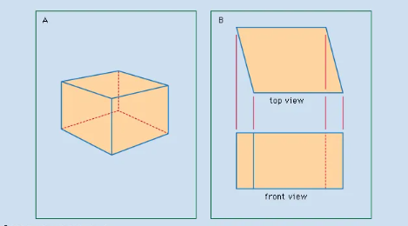

**P1 Met I would like a little more on3D though, especially now you have used 3D software to explain the concepts.**

Using colors and shapes, 3D graphics allow the creation of three-dimensional objects through a set of techniques and tools. There is many different software available which you can try on, for example 3DS max, Daz 3D, 3D slashes, thinker CAD and many others. There are also multiple different tools which you can use to help you create the perfect 3D model you want. For example, you can use a scale tool to Strech out your shape, move tool to move it around, rotate tool to turn it around, group tool so you can freely move 2 or more shapes together. You can even use the viewports and camera angles to look at your design from a different view. If you are interested in creating an animation, you can use the rendering tool to get some shots of your project which can be used for a stop motion.

**P2 – Not met You need to talk about the different file types, the compression methods used, the impact on quality etc. I would expect to see a table of file types with relative strengths and weaknesses and discussion of compression and quality.**

**M1 Not met - You need to explain a LOT more about the several factors that can affect the quality of an image and its size. Breaking down the different file types with comments on compression etc., how that affects the image. We did a ton of work on this in class. Esp week 3, and week 8**

**D1 Not met Follows on from M1, where you compare various formats, discussing the quality and which are most affected by factors such as compression etc.**

|  |  |  |  |
| --- | --- | --- | --- |
| **File type and settings** | **File size** | **Comments on quality etc.** | **image** |
| PSD (no changes) | 5.43 MB | High quality image. |  |
| JPG (100% Quality) | 687 KB / 704.162 bytes | File size drops, image uses less colors which makes it looked smudged. |  |
| JPG (50% Quality) | 119 KB / 122.826 bytes | File size drops, not much difference from 100% and extremely hard to spot changed |  |
| JPG (20% Quality) | 64.1KB / 65.708 bytes | Smaller file size, image looks similar but very blocky when you zoom in |  |
| PNG (24 bit) | 1.47 MB / 1,543.335 bytes | File size increased, photo looks in-between jpg 100% and 50%. There are no big pixels appearing(blocky). There is not much smudge of color |  |
| GIF | 497 KB / 509.180 bytes | Areas of the photo look like they have been compressed. As you zoom in you can see loss of quality, lots of pixels (blocks) appearing Aswell as multiple shaded of color. |  |

|  |  |  |  |
| --- | --- | --- | --- |
| **Size and Filetype** | **File size** | **Comments on Quality etc.** | **image** |
| PSD (500 x 500) |  |  |  |
| PNG (500 x 500) | 495 KB / 507.247 bytes | File size is compress by 1mb just by adjusting the size of the image. The photo looks like before; once zoomed in, you can start to see pixels and different shades of color. |  |
| GIF (500 x 500) | 143 KB / 146.754 bytes | Due to compressing the image size, the file size has also decreased. You can tell right away it has been compressed, with a lot less use of color which results in more smudges. The photo is still clear but vastly different from the original. When zoomed, the image appears very pixelated and smudged. |  |
| JPG 100% (500 x 500) | 100% 252 KB / 258.419 bytes  Lowest quality % drops to 17KB | Better quality than GIF and this jpg has a less smudge compared to Png.  Image looks quality has not decreased much from 1000x1000 jpg 50%. |  |

|  |  |
| --- | --- |
| **Changes made** | **Effects** |
| Adjusting brightness and contrast | Inserting image...Low brightness low contrast, photo is very dark, still noticeably clear when zoomed in, not pixelated, or smudged. The bit depth remains the same. File size = 1.21 MB, origin was 5.43 MB, reducing brightness and contrast has a big decrease on file size.  Inserting image...High brightness, sharp contrast. This makes the image look very vibrant and make u think they have used less but brighter colors. The areas of the photo look more smudged with less use of color shaded. although Image does not look pixelated it looks very smudged. File size= 1.27 KB,higher than poor brightness and contrast but much less than original I think due to color depth |
| Adjusting Hue/Saturation settings | Inserting image...Low hue and saturation make the image monochrome of only 2 colors (black and white.) quality of the image looks the same, no pixelated / smudged areas. File size, which was originally 5.43 MB drops drastically to 773 KB  Inserting image...High hue and saturation contrast to low which gives our image an extremely high rgb overall color with a few other shades. The main colors displayed are red and blue alongside other shades. file size has decreased from 5.43 MB to 1.31MB. |
| Adjusting Color Balance settings | Inserting image...You can use this color balance scale to make your image have an overall shade. If you try to increase all values to poor or high like this example below:  Inserting image...Inserting image...  This will make your image go back to the original. Which will allow the image to keep the same file size and resolution. |
| Inverting the image | Inserting image...To the left is the image I received when I inverted the image. The effect taking place in the invert tool is: photoshop is flipping your colors from RGB to CMY. This links with the color balance settings. If my image was on red 50 green 25 and I invert the image with this tool, I will result in cyan -50 and green –25. Using this effect dropped out file size from 5.43 down to 1.46 MB |

|  |  |
| --- | --- |
| **Changes made** | **Effects** |
| Greyscale | Applying greyscale to your image gives you the same result as low hue and saturation. Once again, the image uses an incredibly low color bit depth which gives a monochrome image. Applying this effect has dropped the image file size down by 4.6 KBInserting image...  Inserting image... |

----------------------------------------------------------------------------------------------

**A3 Digital animation techniques**   
**Characteristics, application, and implications of using digital animation techniques to create and process 2D and 3D animated images.**

**1.c**

**Key frames**

Nowadays, keyframes are related to video editing. However, they originated from animations prolonged before digital video editing.

Key frames are used in animations to show the movement to viewers. However, this is only made up of two shots. For most editing software, the start and end of the parameter change is needed.

During recordings of animations, the start and end point has a smooth transition, known as a key frame. This can be a drawing or a shot animation.

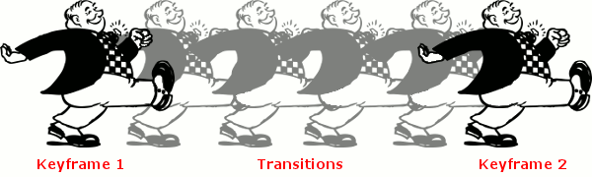

**Tweening**

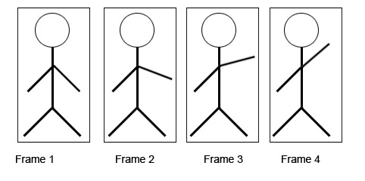

Tweening has been around in the animation genre since the 1940’s. However, the first example was shown in the opening credits of Vertigo by Alfred Hitchcock. [**Vertigo (1958) - First computer animation ever! (HD)**](https://youtu.be/GQwp6M2q1NE)

[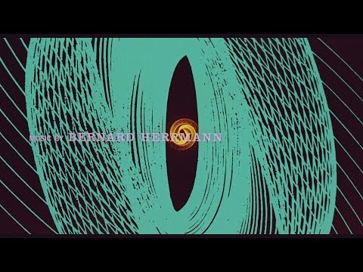](https://youtu.be/GQwp6M2q1NE)

Tweening is CGI, CGI stands for computer generated imagery. Tweening generates a morph or a moveable component from 2 keyframes. Studies show that the most basic level of tweening is moving a circle from one side to the other horizontally.

In animation context, tweening is simply the in-between of the keyframes. For example, if you have a start and end keyframe then tweening will be the transition which is in-between both keyframes.

The goal of tweening animation is extracted onto moving objects. It also focuses on the:

* Color
* Size
* Transparency
* Form
* Transitions

**Motion capture**

The animation technique of motion capture has been around since the early 1900s. It was first used in a short film by max Fleischer in 1915.

Filming the movement of items or individuals is called motion capture. Using motion capture techniques, movement may be captured and turned into 3d graphics for shows or films. Motion capture is done by using markings and detectors that are affixed on a person or thing.

Animated film creation can be enhanced by motion capture, which is simple and inexpensive. Compared to manually key-framing animation, recording animation is faster.

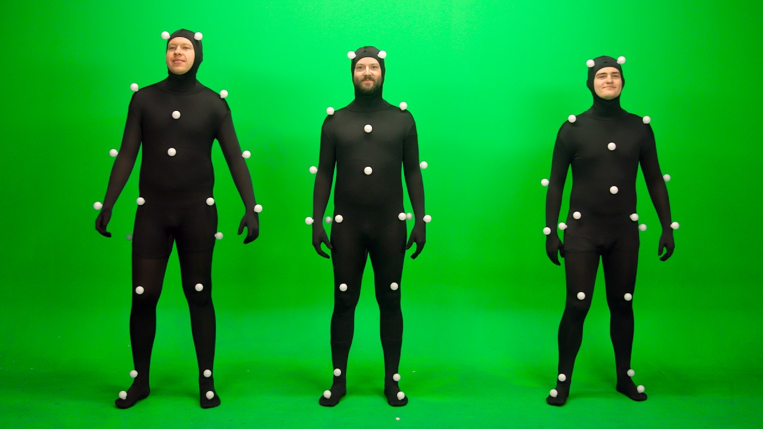

Advantages of using motion capture:

* minimal delays
* Believable
* Somebody can generate a lot of motion footage.

**Wire framing**

A wireframe is a two-dimensional representation of a page's interface that focuses on the allocation of content space, the order in which it should be displayed, the functionalities that are available, and the desired behaviors. When the maps and even the polygon faces are removed from a 3D model, what remains are the outlines of its component polygons, which are made up of vector points connected by lines. This is what is known as a wireframe. The terms "wire mesh" and "wireframe" are interchangeable. In fact, the term "wireframe" existed before it was used in web design. Computer aided design (CAD) first utilized wireframes to display 3D objects (CAD).

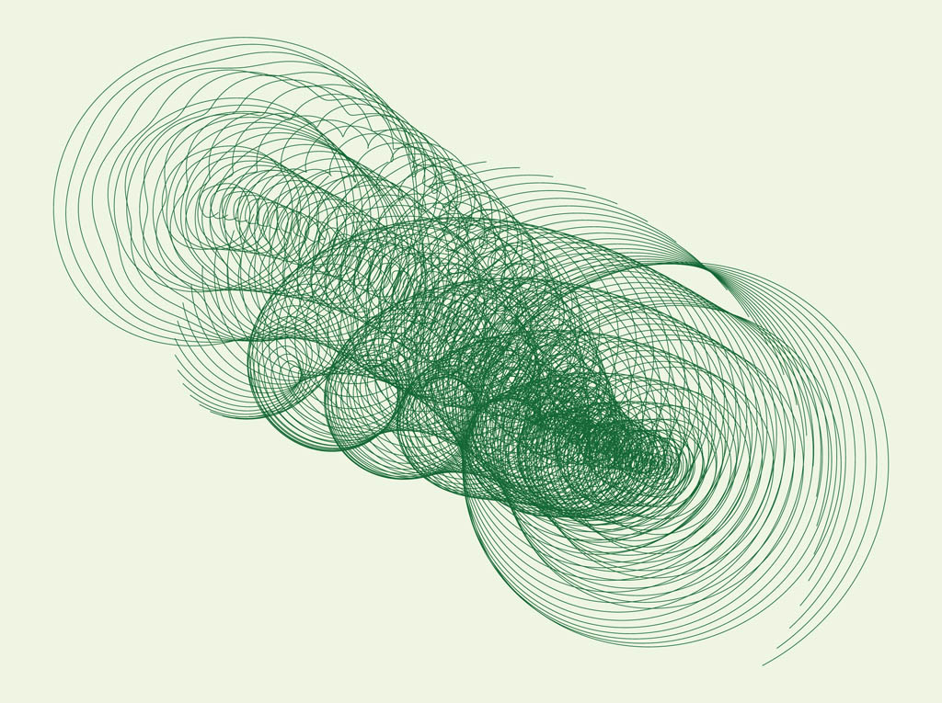

**Coordinate Systems**

A coordinate system is a method for figuring out where a point or other three - dimensional object is located within a greater area structure. Users can use the graph to locate their image on a bigger framework or even a specific part. To do this, we use the XY graph.

**Environmental physics**

Animated world physics are demonstrated in this manner. An object might genuinely fall and bounce by just being affected by gravity. It might be demonstrating how the wind affects clothing or hair, causing it to sway in the breeze.

Additionally, rendering physical systems like making water flow, smoke billow, or flames burn within an animated environment is also covered by this.

Animation professionals must understand the physics involved in depicting all these things. Alternatively, the software tools must contain functions that let animators automatically apply such physical rules.

**Behavioural animations**

Behavioural animation is when Computer animation is a subset of procedural animation, which includes behavioural animation. An autonomous character in behavioural animation, at least to some part, controls its own behaviour.

Advantages:

* Cost effective
* Interactive
* Learner directed

Disadvantages:

* Loss of creativity
* Expertise
* Simplicity

**1.d**

**Explain how a range of factors can affect the final quality of a digital image:**

* Platform
* Medium
* File format
* Tools used

Platforms can be divided into two sections. Device kinds are the first. This might impact how your image turns out. For instance, a shot taken with a phone or camera of inferior quality will not appear as good as one taken with a better camera or phone.

Software is yet another category of platform. You may have to pay a price to utilize some software. This can imply that the software will have more tools at your disposal to enhance your image.

With a few notable exceptions, medium format cameras typically have sensors with resolutions between 50MP and 100MP, higher than most smaller format cameras. The ability to distinguish finer, more minute details at a distance is made possible by the increased number of pixels in an image.

While doing this, some formats sacrifice quality (JPG reduces file size by lowering quality, although not always by a perceptible amount). These file formats are referred to as LOSSY. Other formats, such PSD or TIFF, do not affect quality at all but do not provide as much file size reduction.

A few internet tools are provided below that can be used to improve the quality of your images:

- Let us Enhance

- Adobe Spark

- Pixlr

- AI Image Enlarger

- Fotor

**How does the target audience impact on what the final images should look like in terms of quality and usability?**

We will need to redesign it if the target audience does not like it. Always keep in mind the needs of your intended audience. The user could request that you blur the background or regions. An editing tool will be used to accomplish this. The customer might also need a higher-quality image; therefore, you will need to alter the file format used for saving.

**How would the purpose of the image impact on choices in creating a digital image? e.g., education, entertainment, illustration**

The digital image should be appropriate if it is being used for educational purposes. Age and gender will typically have an impact on the image. We can also use larger fonts and more colours if we are aiming at a younger audience. Less colorful and simpler typefaces are preferable to sophisticated writing when addressing an older audience.

**What are the legal and ethical considerations one should be aware of when creating digital images?**

There are a few laws and ethics which must be followed when creating a digital image. The most common is the Copyright, Designs and Patents Act 1988. This gives you creativity of a design, music, or any illustration. By using someone Elses can get you into trouble. When creating a digital image, you must create your own and not use others unless they give you permission, which can be done by contacting them and making an agreement (cash fee).

Another legal and ethical consideration, also well known, is the current law governing trademark registration and registered trademark protection in the UK is the Trademarks Act 1994, as amended. trademark can also be found in images just like copyright. 